ASP .Net CURD Operations

Steps:

- Choose ASP. Net Web Form Site option and click on “OK”
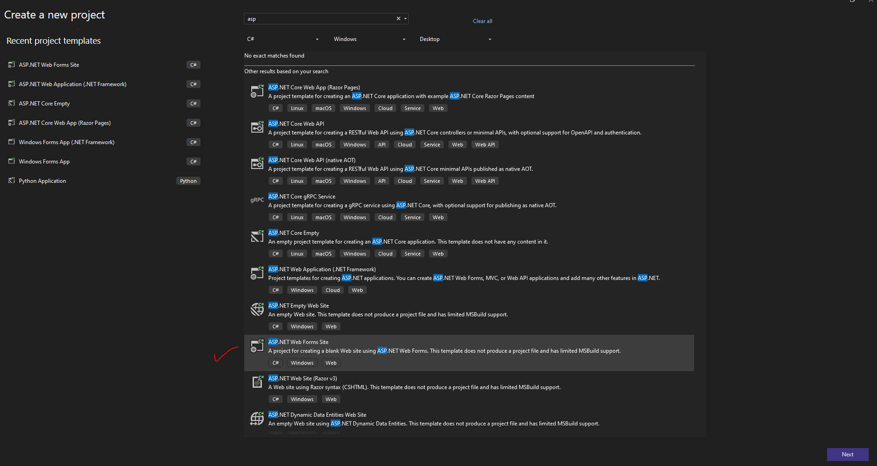

- Add Code into Default.aspx file

<asp:Content ID="BodyContent" ContentPlaceHolderID="MainContent" runat="server">

<div>
<div style="font-size: x-large" align="center"> Student Information Managment Form</div>
</div>
<br/>

</asp:Content>

- Now add a table

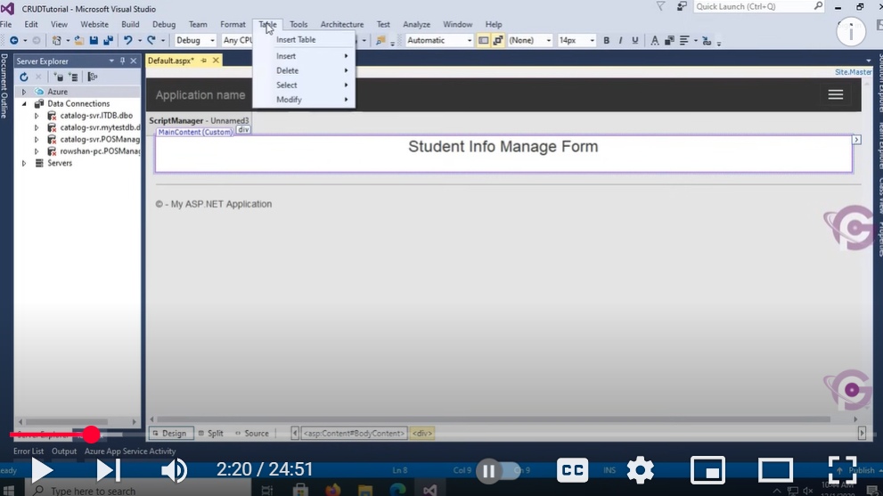

Add Rows and column and design below form by add elements from Toolbox

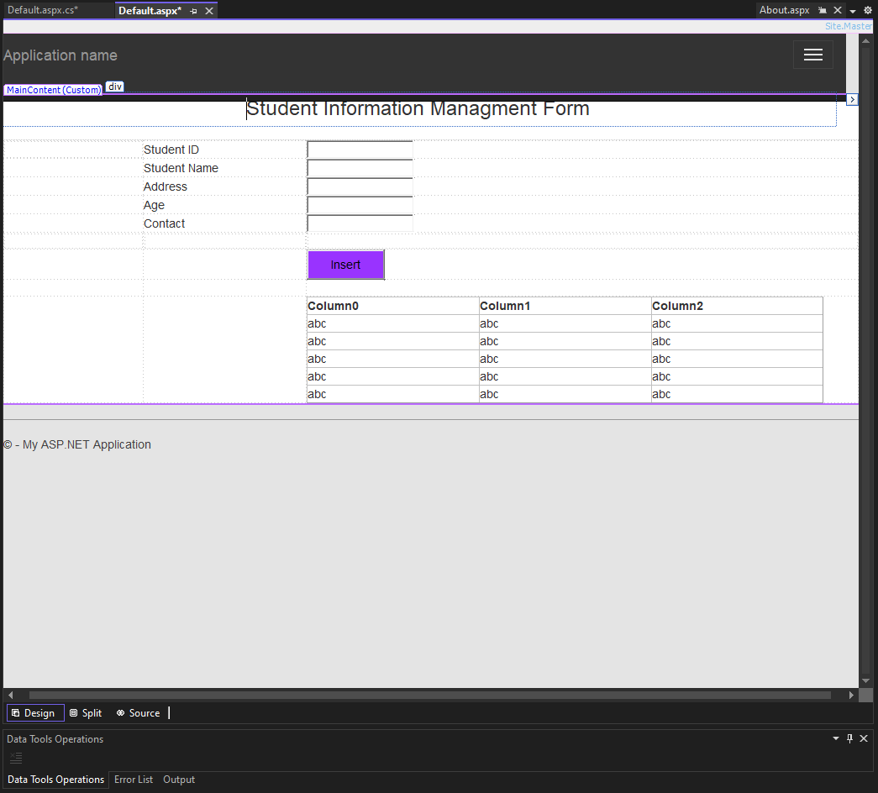

Now create a database and connect it the web form with it

After that write method behind Insert button

public partial class _Default : Page
{
protected void Page_Load(object sender, EventArgs e)
{
if (!IsPostBack)
{
LoadRecord();
}
}

SqlConnection conn = new SqlConnection("Data Source=(LocalDB)\\MSSQLLocalDB;AttachDbFilename=C:\\Users\\P1\\source\\repos\\AspCurdOperation\\App_Data\\StudentManagmentDb.mdf;Integrated Security=True");

protected void Insert_Click(object sender, EventArgs e)
{

conn.Open();
SqlCommand comm = new SqlCommand("Insert into StudentInfo values('" + StudentId.Text+ "','" + StudentName.Text + "','" + Address.Text+ "','" + Age.Text + "', '" +Contact.Text+"')", conn);
comm.ExecuteNonQuery();
conn.Close();
ScriptManager.RegisterStartupScript(this, this.GetType(), "script", "alert('Successfully Inserted');", true);
LoadRecord();
}

void LoadRecord()
{
SqlCommand comm = new SqlCommand("select * from StudentInfo", conn);
SqlDataAdapter d = new SqlDataAdapter(comm);
DataTable dt = new DataTable();
d.Fill(dt);
GridView1.DataSourceID = null;
GridView1.DataSource = dt;
GridView1.DataBind();
}
}

Lab Task: Perform Update and Delete operation in above created form

